

ISP

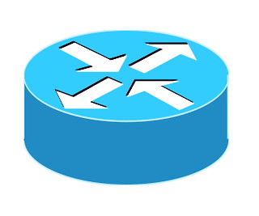

Figure Router -  
It acts as the gateway between the internal network and the external Internet. Translates private IP addresses used within the office network into a single public IP address assigned by the Internet Service Provider (ISP).





Figure 4 Access Switch -   
Connects devices within the office, providing scalability. Having two access switches provides redundancy and improves network performance.

Figure 5  
Workstation 1

Figure 7  
Workstation 3

Figure 6  
Workstation 2

Figure Core Switch -  
is the central hub of a network. It is responsible for connecting all different parts of the network together ensuring efficient data transfer

Figure Access Switch

Figure 2 Firewall -  
Enhances security by controlling and monitoring incoming and outgoing network traffic.